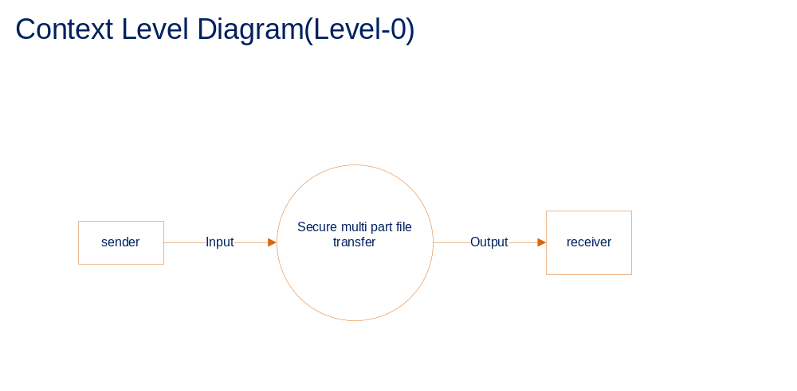Sender:
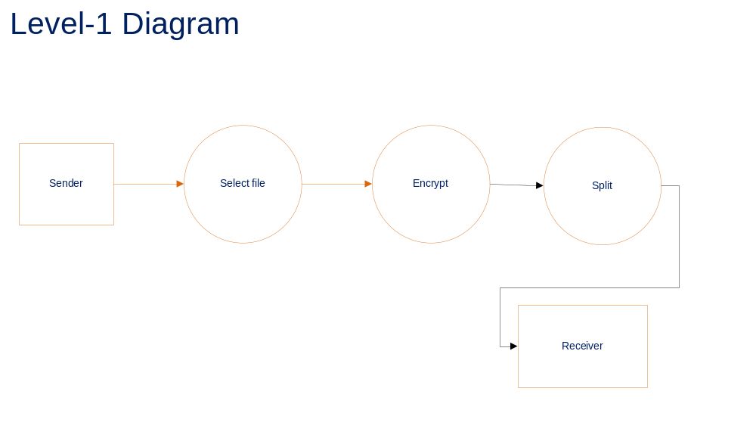

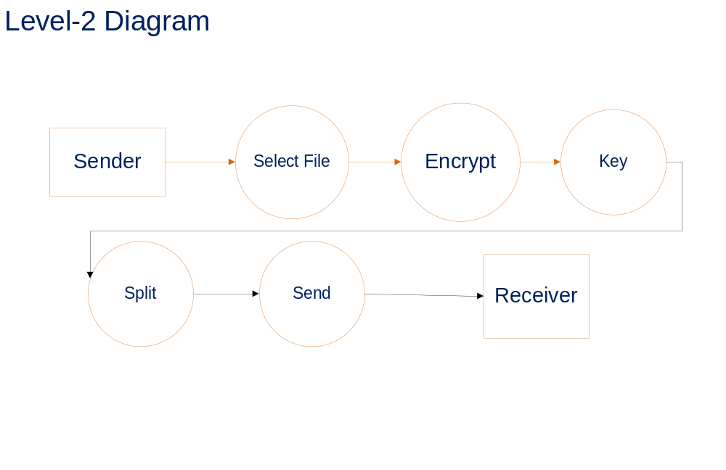

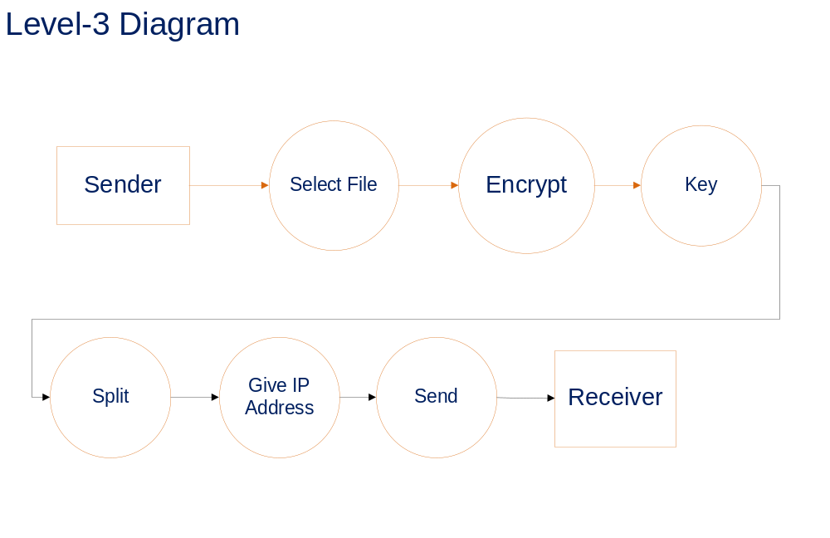

Receiver:
EMBED Visio.Drawing.11 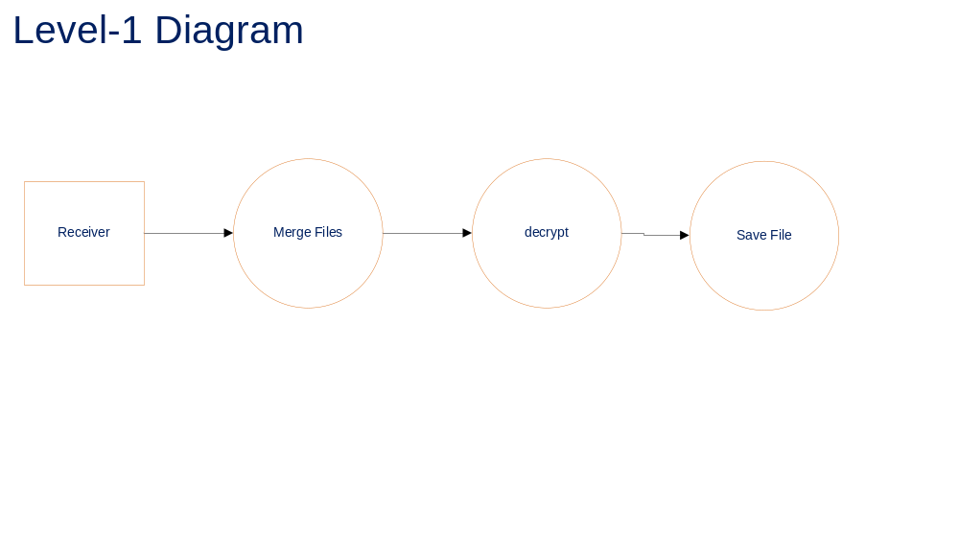
EMBED Visio.Drawing.11 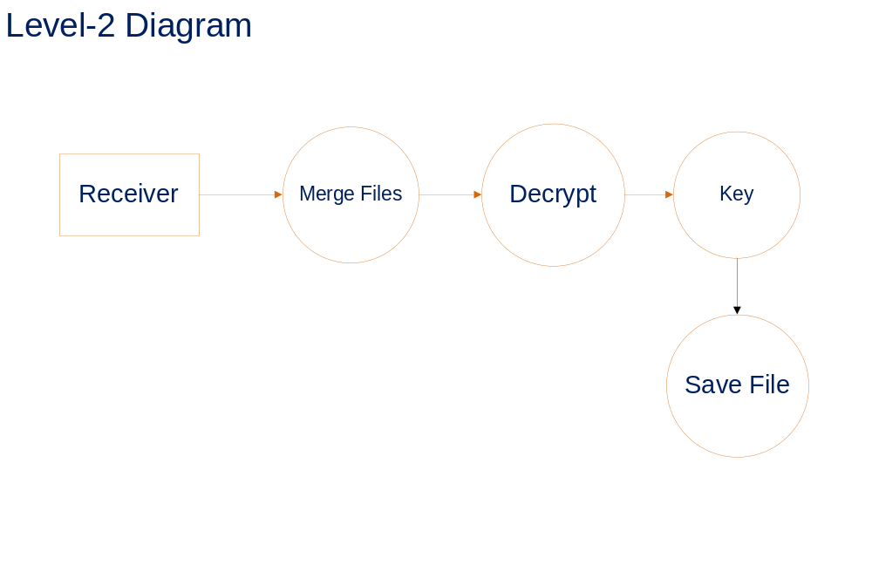

Architecture Diagram:
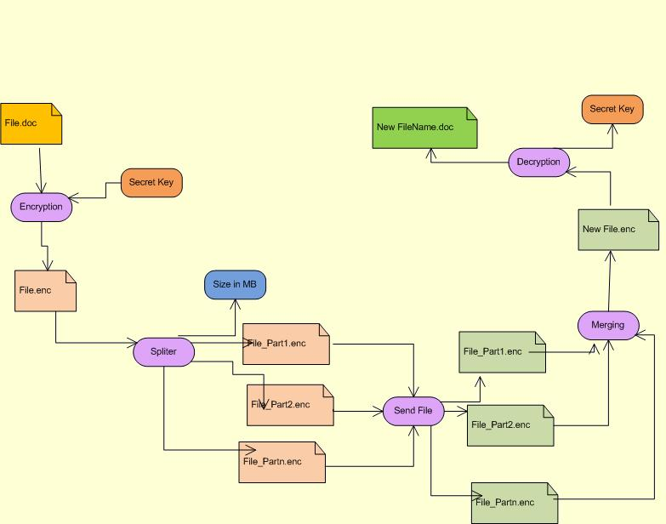
Use case Diagram
Sender:
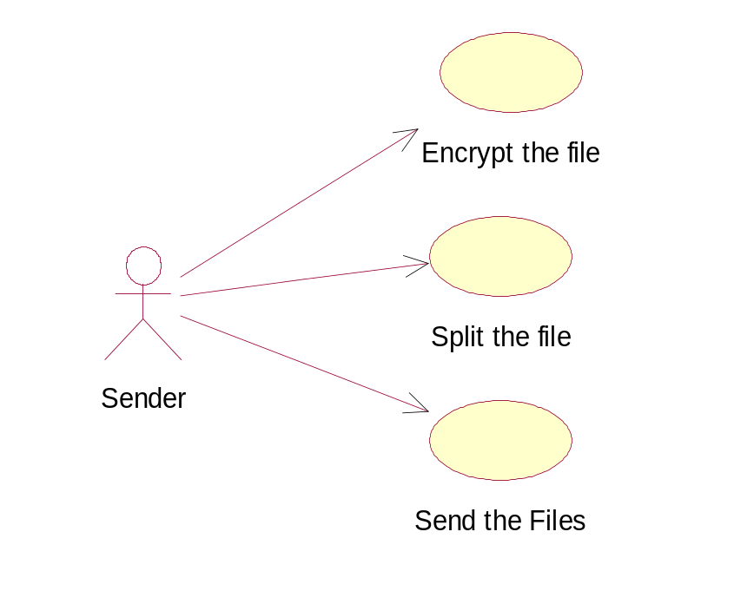
Receiver:

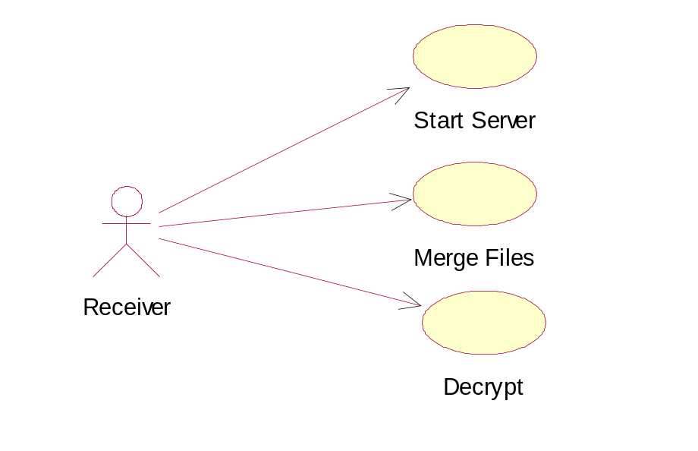

Class Diagram:
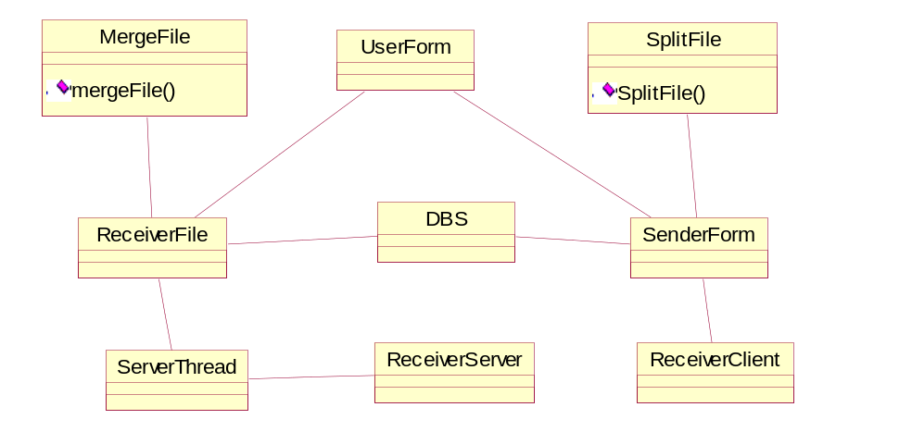

Sequence Diagrams
Sender
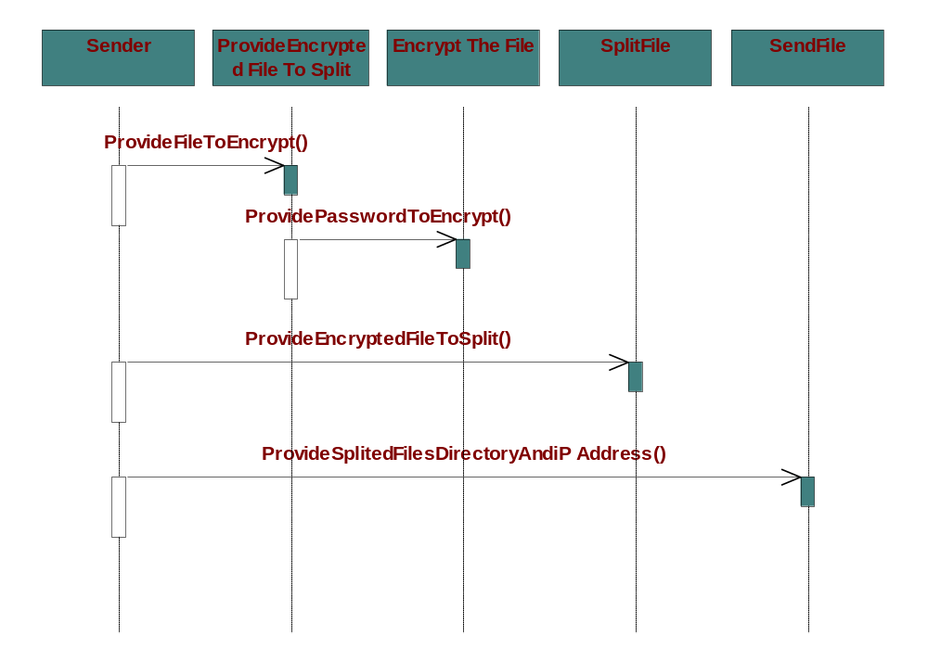

Receiver:
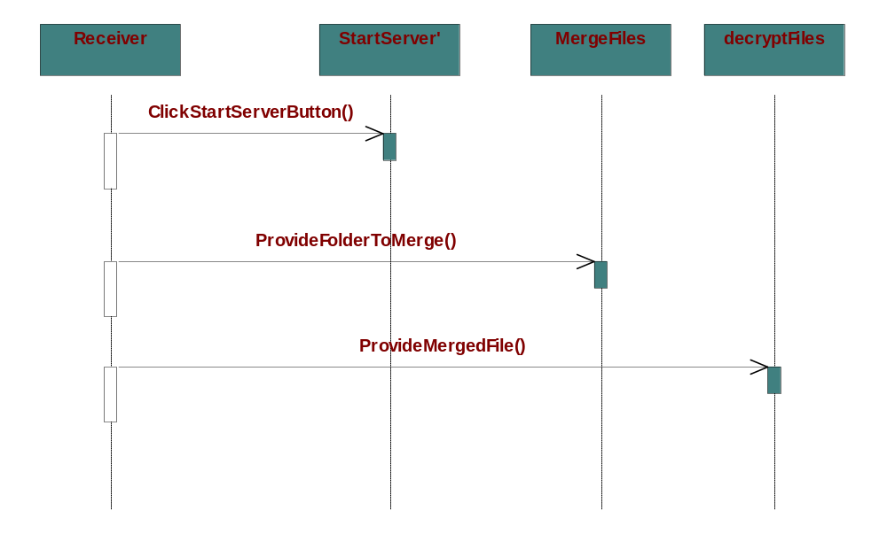

Collaboration Diagram:
Sender:
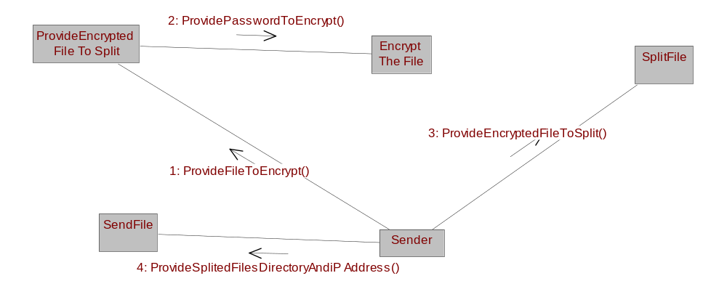

Receiver:
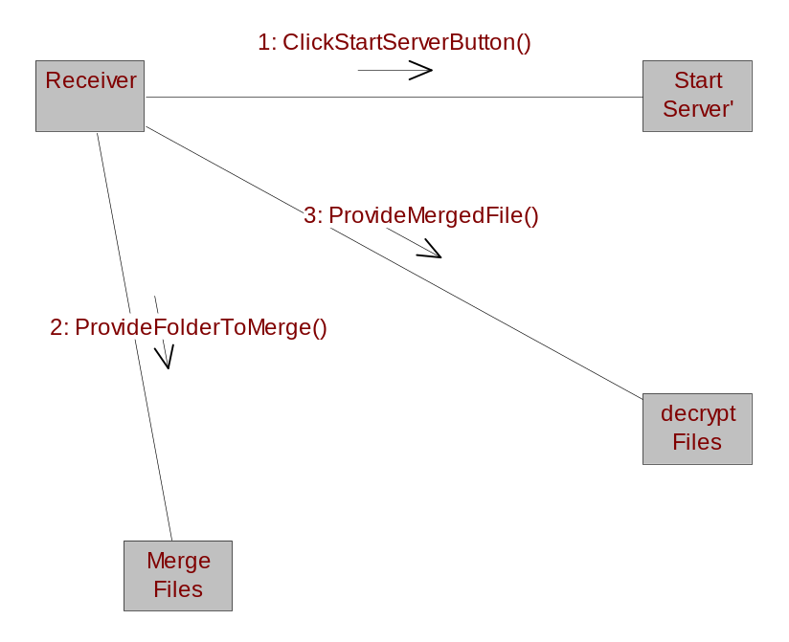

Activity Diagram for Encryption, Splitting & Sending
Sender
Encryption System
Receiver
Save with Alternative name
Select file name
Supply Encryption
Apply Encryption with Key
Search for the file
Not found
Select file name
Supply Encryption
Apply Encryption with Key
Search for the file
Not found

Found File

Select the Saving
Option

Save with Alternative name

Select file name
Search for the Encrypted File

Not found
Found File
Supply Encryption
Apply Splitting Process
Request IP
Search for IP
Take confirmation
Found IP
Not Found

Transfer the File
Save the File

Activity Diagram for Merging & Decryption
Decryption System
Receiver

Select the Folder

Search for the file
Supply Encryption
Not found
Apply Merging
Select the Saving
Option

Save with Alternative name
Select file name
Search for the Encrypted File
Not found

Supply Encryption
Apply Decryption with Key

Select the Saving
Option
Save with Alternative name

Deployment Diagram
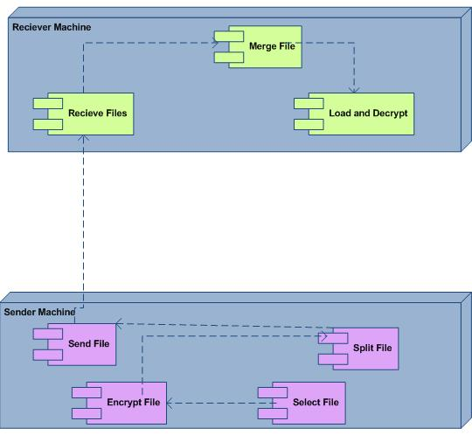
Component Diagram:
